**HANOI UNIVERSITY OF SCIENCE AND TECHNOLOGY**



**PROJECT REPORT**

DATABASE DESIGN AND IMPLEMENTATION

MANAGERMENT SYSTEM FOR CLOTHES STORE

**GROUP 2**

**NGUYỄN THỊ LINH**

[linh.nt200349@sis.hust.edu.vn](mailto:linh.nt200349@sis.hust.edu.vn)

**VŨ MINH DŨNG**

[dung.vm205179@sis.hust.edu.vn](mailto:dung.vm205179@sis.hust.edu.vn)

**NGUYỄN TẤN TIẾN**

[tien.nt205172@sis.hust.edu.vn](mailto:tien.nt205172@sis.hust.edu.vn)

**Major: Global ICT – IT-E7 – K65**

**Specialization: UNDERGRADUATE**

**Supervisor:** Associate Professor Vũ Tuyết Trinh

Signature

**Department:** Computer Engineering

**School:** School of Information and Communications Technology

HANOI, 02/2023

Table of Contents

I. Acknowledgement 4

II. Team members and Work Allocation 4

1. Team Members 4

2. Responsibility 4

III. Problem description 4

Entity 5

1. Customers (Manage customers’ information) 7

2. Products (Manage products’ information) 8

3. Orders (Manage different orders) 8

4. Orderlines (Connect the orders and products) 8

5. Staffs (Manage staff’s information) 9

6. Product_history (Track the import of goods into the store) 9

7. Discount (Manage discounts) 9

8. Price_history.(Track the changes of price of products) 10

9. Categories (manage different categories of products) 10

IV. Demonstration and analysis: 11

1. TRIGGER AND VIEW 11

**a.** **Auto insert new row into price_history when updating sale_price of product** 11

**b.** **Trigger update quan_in_stock of products when importing (insert on product_history)** 12

**c.** **Update quan_in_stock of product when check-out (an orderline is created)** 13

**d.** **Check quantity of orderline before inserting:** 14

**e.** **View to join products, discount:** 14

**f.** **Trigger to calculate total amount, discount, point… when an orderline is created:** 14

2. FUNCTION AND VIEW: 15

**a.** **Update discount_id for all item of store** 15

**b.** **Update discount_id for certain category_id** 16

**c.** **Calculate total_amount for certain period** 17

**d.** **Function to show sale history of staff** 17

**e.** **Function to show history between a period of time** 19

**f.** **Function show history of a customer - according to customers' phone (using view)** 20

**g.** **Function to show changes in Price of a product (Query by pattern of product_id)** 21

**h.** **Function to find product of the same category (search by category name)** 22

**i.** **Function to show the money coming in and out through a period** 23

**j.** **Function shows the sum of money coming in and out in a period** 23

**k.** **Function filters order by total_amount** 24

3. ANALYSE USING VIEW 24

**a.** **Query without view:** 24

**b.** **With view, the query is simpler:** 25

4. ANALYSE USING INDEXS 25

**a.** **Without index:** 25

**b.** **Using BTREE index:** 26

**c.** **Using HASH index:** 27

V. User Interface 29

1. Manage Staffs 29

2. Manage Customers 30

3. Manage Products 30

4. Manage Orders 31

VI. Lesson learned from this project 32

# **Acknowledgement**

I would like to thank my beloved professor Mrs. Trinh Vu Tuyet, who allowed me to work on this project and provided all the support and guidelines that I need. I got to learn a lot from this project about the way we use databases to store, retrieve, and process data. Since my goal is to become a Data Analyst, this project means a lot to me.

I would like to thank my dear group members – Ms. Linh Nguyen Thi and Mr. Dung Vu Minh who have made their best efforts to make this project successful. Without their support, this project would not have been possible.

# **Team members and Work Allocation**

## **Team Members**

|  |  |  |  |
| --- | --- | --- | --- |
| **STT** | **Name** | **Student ID** | **Role** |
| 1 | Nguyễn Thị Linh | 20200349 | Leader |
| 2 | Nguyễn Tấn Tiến | 20205172 | Member |
| 3 | Vũ Minh Dũng | 20205197 | Member |

## **Responsibility**

|  |  |  |
| --- | --- | --- |
| **STT** | **Work** | **Members** |
| 1 | Overall Design | Linh, Tiến, Dũng |
| 2 | Entity Relationship Diagram | Linh, Tiến, Dũng |
| 3 | Schema and Mapping | Linh, Dũng |
| 4 | Create view, function and trigger | Linh, Tiến |
| 5 | Insert Data | Dũng |
| 6 | Write Query | Linh, Tiến, Dũng |
| 7 | Analyze the use of view, index | Linh |
| 8 | Database connection + GUI | Dũng |
| 9 | Write report | Tiến |

# **Problem description**

* **Purpose:**

It is a fact that the number of small businesses selling clothes is heavily expanding with every passing day, and so does the need to have an efficient and effective management system for those products. Such a system provides a user-friendly way for staff to control what is available inside the store, know who a regular customer is and also allow business owners to control the amount of money coming in and out, and to examine staffs’ performance. Thus, our team choose this problem with the hope to provide a simple, yet robust solution so that everyone can become business owners. Please note that this database design should only be effective with small businesses whose number of warehouses is one. For larger corporations, the proposed design might be not be suitable.

* **Users:**
  + Managers: the manager can update, insert, and delete products of the store. The manager can also track the performance of the staff by assessing the selling history of the staff that he/she manages. Finally, the manager also handles the imports of goods into the store.
  + Staff: These people are day-to-day workers that serve the customers. Staff can view the products that are available instore and create orders containing those products. The staff can create new customer record and adjust the information of the existing ones if anything changes. (Finally, the staff also handle the returns of products should the customers are dissatisfied)
* **Main triggers required:**
  + Auto update the number of available products of each type after a purchase has been made.
  + Auto check whether the number of products ordered by an order exceeds the number of that product in stock
  + Auto update the number of available products of a certain type after an import been made
  + Auto count total price, discount percent for orderliness, orders and update the credit and the rank of customers after a purchase been made.
* **Main functions required:**
  + Staff and Manager can check the purchase history of all customers in a certain time period. (E.g.: Query all orders placed between the 1st and the 31st of January, 2023).
  + Staff and Manager can check the purchase history of one customer (using their mobile phone number as input)
  + Manager can see the changes in price of a single product
  + Manager can see the flow of money (in and out) from a certain period.
  + Manager can see the sum of money (in and out) from a certain period
  + Staff can find all products of the same category
  + Staff can find certain products based on the pattern of their names
* **Constraints:**
  + Customers can only purchase products whose quantity is greater than 1
  + Whenever a new product is created, the ID of the product will be checked according to the format: MODEL-COLOR-SIZE. E.g.: 12345-RE-M: Model: 12345, Color: Red, Size: M
  + Each type of product will be subjected to none, one, or many discount. The discounted price will be calculated automatically.
  + Customer can sign up with the staff to be close customers (holding a customer record). After each purchase, the customer will receive a certain amount of credit amounting to 10% of the final bill. There are four levels of customers: Copper (point < 10), Silver (10 <= point<=99), Gold (100 <= point<=499), and Diamond (point>=500). There will be different discounts for different rankings.

## Entity

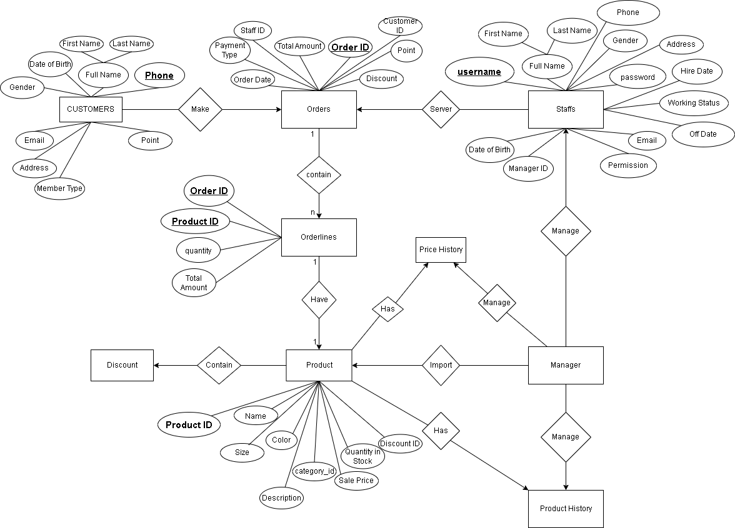

Figure 2: Entity-Relationship Diagram

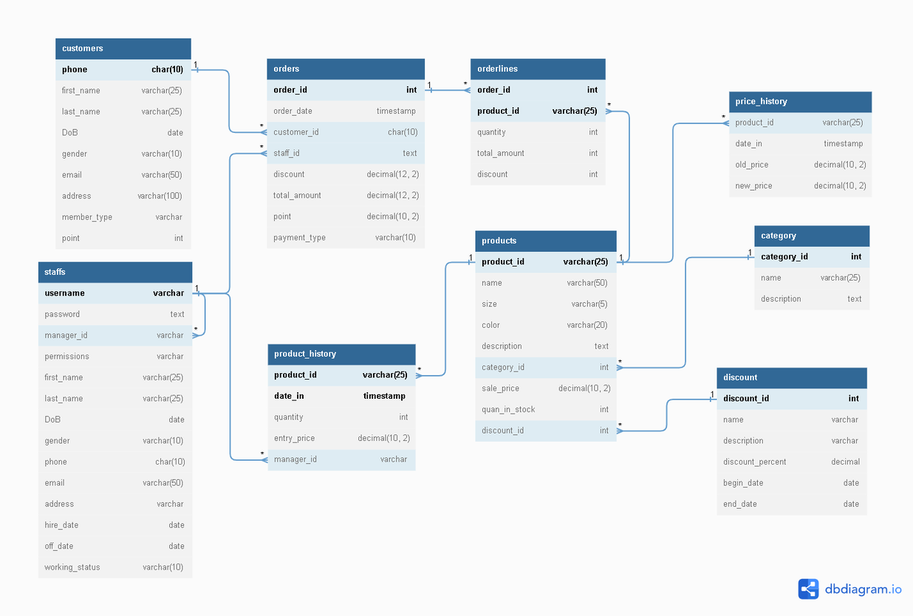

Figure 1. Table Schema and Mapping

## **Customers (Manage customers’ information)**

|  |  |  |
| --- | --- | --- |
| **No** | **Attributes** | **Explanations** |
| 1 | **phone** | User’s personal phone number – the primary key |
| 2 | first_name |  |
| 3 | last_name |  |
| 4 | DoB | Date of Birth |
| 5 | gender |  |
| 6 | email |  |
| 7 | address |  |
| 8 | member_type | Will be in (‘Copper’, ‘Silver’, ‘Gold’, ‘Diamond’), default ‘copper’ |
| 9 | point | Default 0 |

## **Products (Manage products’ information)**

|  |  |  |
| --- | --- | --- |
| **No** | **Attributes** | **Explanations** |
| 1 | **product_id** | Primary key, using format ‘briefName-Color-Size' (Eg.: FJK-black-S) |
| 2 | name |  |
| 3 | size |  |
| 4 | color |  |
| 5 | description |  |
| 6 | category_id |  |
| 7 | sale_price |  |
| 8 | quan_in_stock |  |
| 9 | *discount_id* | Foreign key references discount(discount_id) |

## **Orders (Manage different orders)**

|  |  |  |
| --- | --- | --- |
| **No** | **Attributes** | **Explanations** |
| 1 | **order_id** |  |
| 2 | order_date |  |
| 3 | *customer_id* | Foreign key references customers(phone) |
| 4 | *staff_id* | Foreign key references staffs(user_name) |
| 5 | discount | Correspond to customer’s member_type |
| 6 | total_amount | Auto calculated |
| 7 | point | Auto calculated, equal to 5% of the total_amount |
| 8 | payment_type | Will be in (‘cash’, ‘card’, ‘banking’) |

## **Orderlines (Connect the orders and products)**

|  |  |  |
| --- | --- | --- |
| **No** | **Attributes** | **Explanations** |
| 1 | ***order_id*** | Prime-key, also foreign key references orders(order_id) |
| 2 | ***product_id*** | Prime-key, also foreign key references products(product_id) |
| 3 | quantity | Must less than or equal quan_in_stock of product |
| 4 | total_amount | Auto calculated |
| 5 | discount | Referenced the discount_id |

## **Staffs (Manage staff’s information)**

|  |  |  |
| --- | --- | --- |
| **No** | **Attributes** | **Explanations** |
| 1 | **username** | Primary key, imply the staff's login account |
| 2 | password |  |
| 3 | manager_id |  |
| 4 | permissions | Will be checked (‘Admin’, ‘Staff’) |
| 5 | first_name |  |
| 6 | last_name |  |
| 7 | DoB | Date of Birth |
| 8 | gender | The gender will be checked in (‘male’, ‘female’) |
| 9 | phone |  |
| 10 | email |  |
| 11 | address |  |
| 12 | hire_date |  |
| 13 | off_date | Default value = “null” |
| 14 | working_status | Default value = “doing” |

## **Product_history (Track the import of goods into the store)**

|  |  |  |
| --- | --- | --- |
| **No** | **Attributes** | **Explaination** |
| 1 | **date_in** | Prime key |
| 2 | ***product_id*** | Prime key, also foreign key references products(product_id) |
| 3 | quantity |  |
| 4 | entry_price |  |
| 5 | *manager_id* | Foreign key references staff(username) |

## **Discount (Manage discounts)**

|  |  |  |
| --- | --- | --- |
| **No** | **Attributes** | **Explaination** |
| 1 | **discount_id** |  |
| 2 | name |  |
| 3 | description |  |
| 4 | discount_percent |  |
| 5 | begin_date |  |
| 6 | end_date | end_date >= begin_date |

## **Price_history.(Track the changes of price of products)**

|  |  |  |
| --- | --- | --- |
| **No** | **Attributes** | **Explaination** |
| 1 | *product_id* | Foreign key references products(product_id) |
| 2 | date_change |  |
| 3 | old_price |  |
| 4 | new_price |  |

## **Categories (manage different categories of products)**

|  |  |  |
| --- | --- | --- |
| **No** | **Attributes** | **Explaination** |
| 1 | **Category_id** |  |
| 2 | name |  |
| 3 | description |  |

# **Demonstration and analysis:**

## **TRIGGER AND VIEW**

### **Auto insert new row into price_history when updating sale_price of product**

**Before update:**

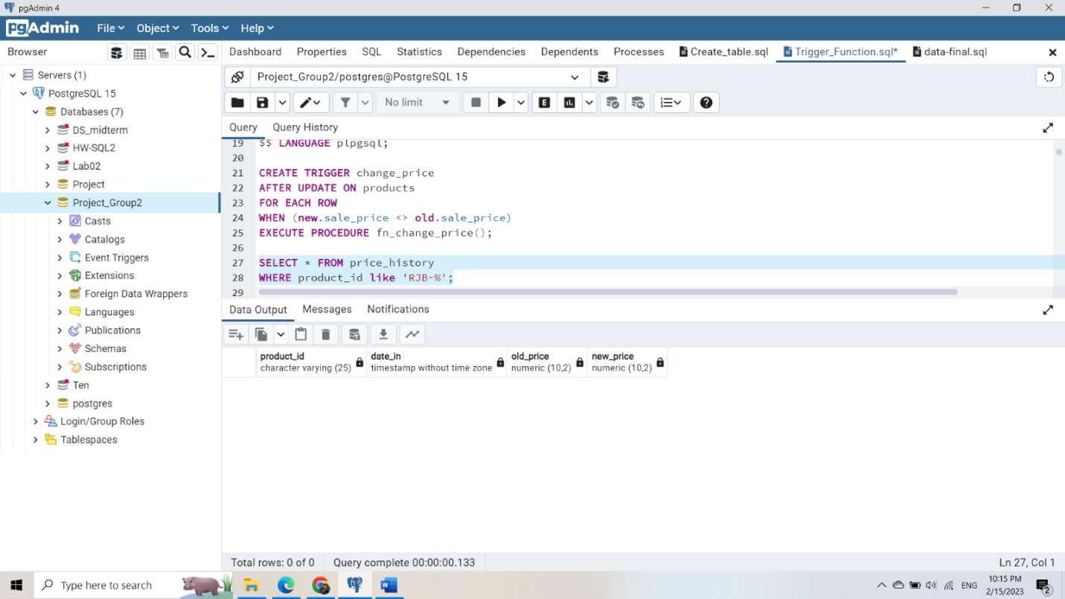

**After update: Some new rows are created**

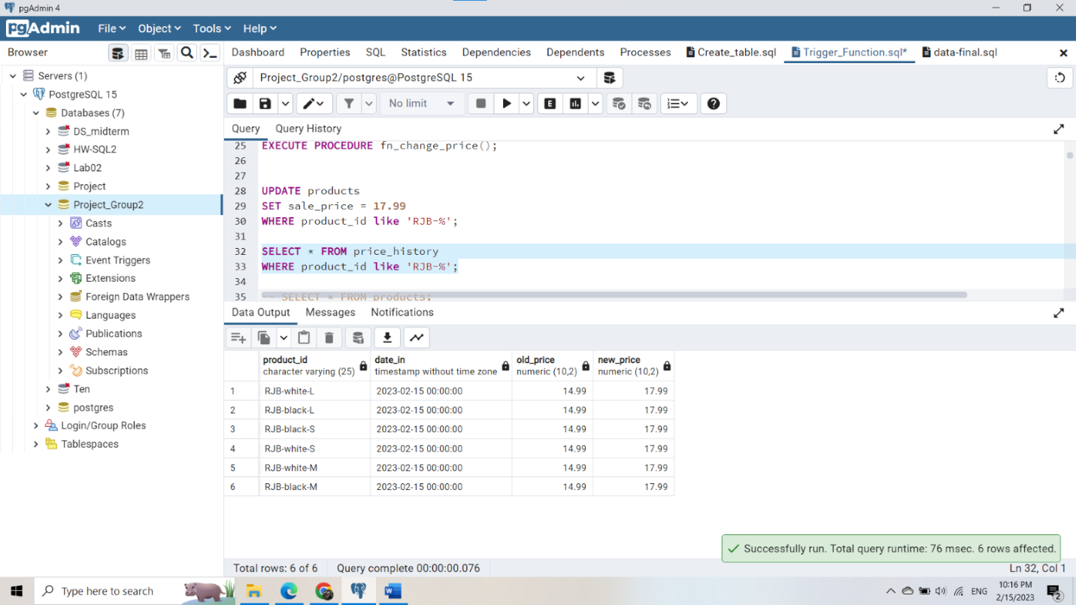

### **Trigger update quan_in_stock of products when importing (insert on product_history)**

**Before insert:**

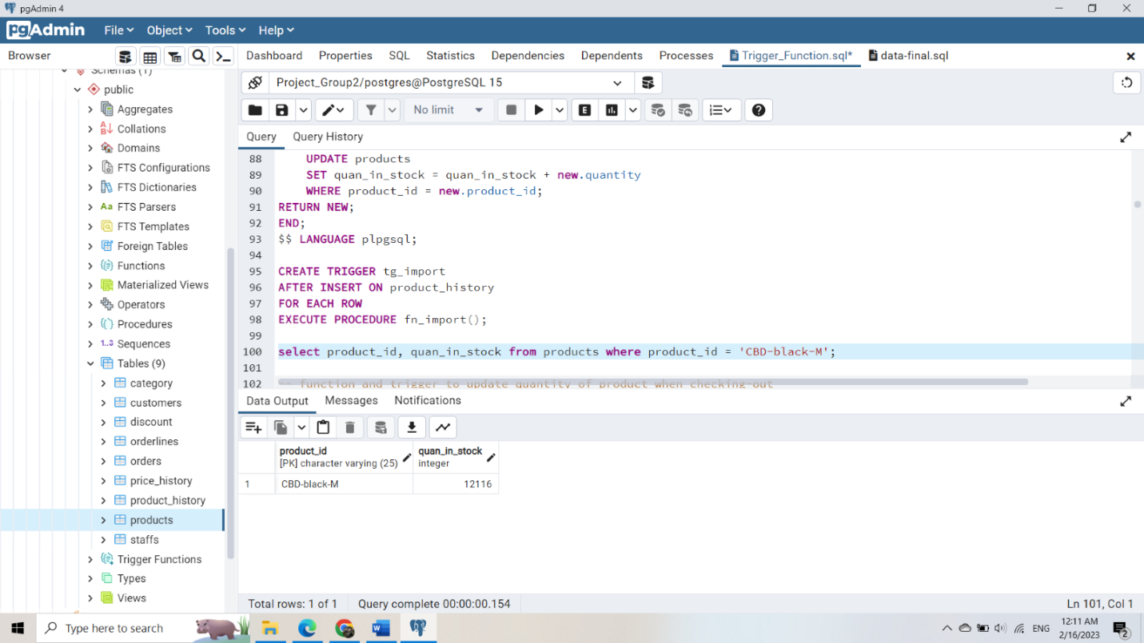

**After insert: quan_in_stock is increased automatically**

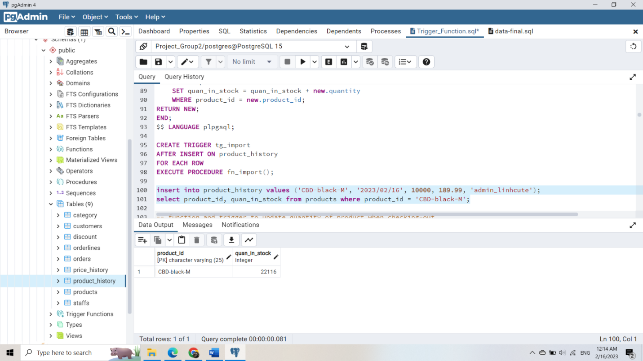

### **Update quan_in_stock of product when check-out (an orderline is created)**

Before insert:

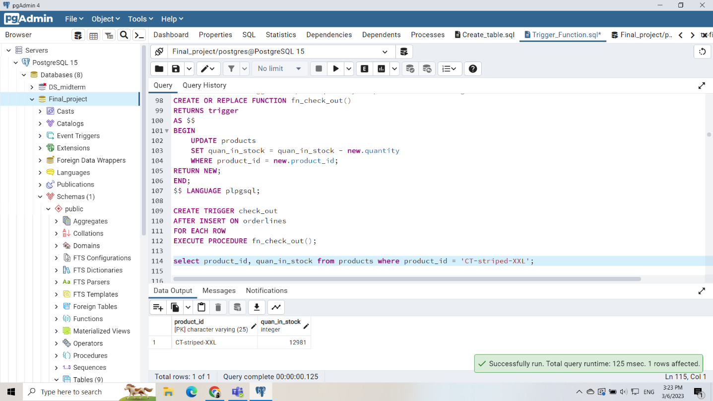

**After insert: quan_in_stock of corresponding product is updated (minus) automatically**

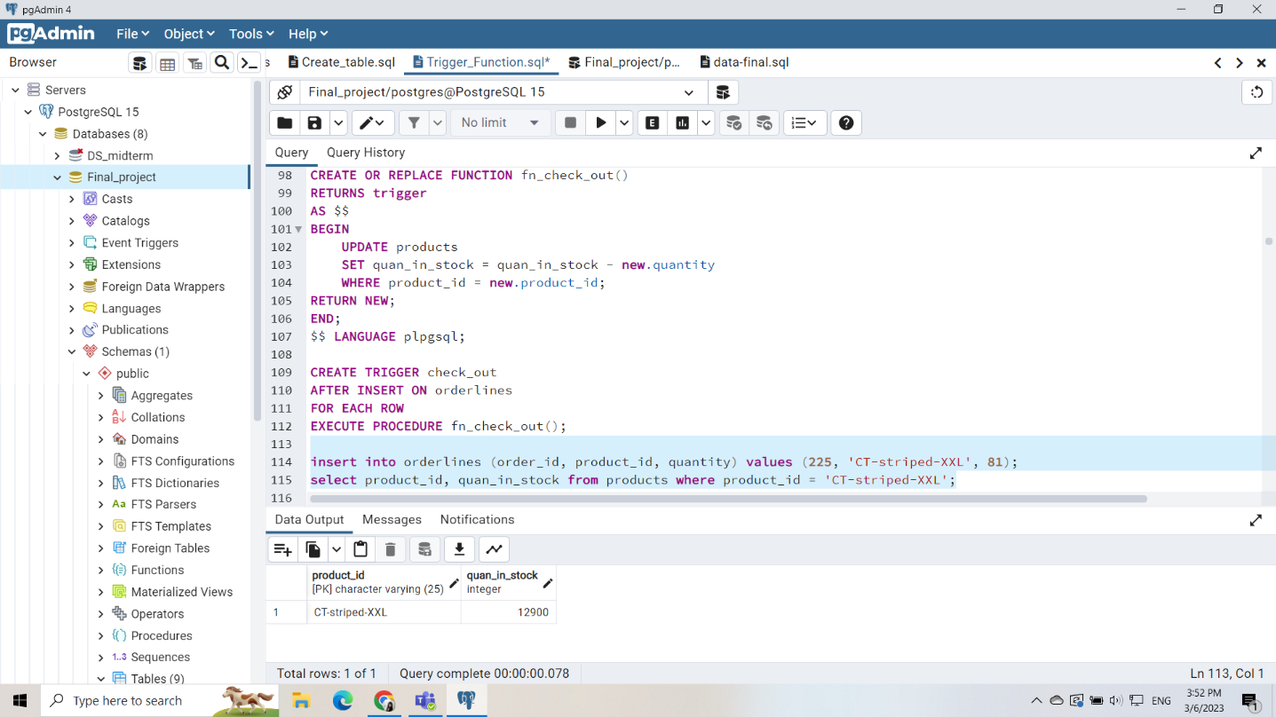

### **Check quantity of orderline before inserting:**

The quantity ordered must less than or equal the quantity in stock, otherwise, it will raise exception

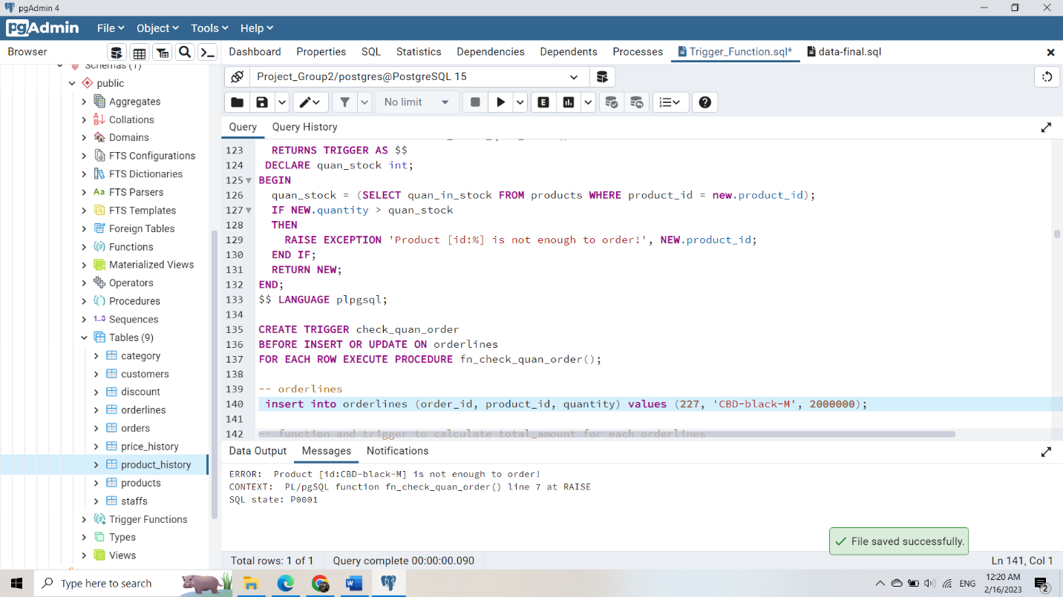

### **View to join products, discount:**

Beneficial in trigger cal_sum_orderlines when we need query to get discount percentage

CREATE VIEW view_prod_dis AS

SELECT product_id, discount_percent

FROM discount, products

WHERE products.discount_id = discount.discount_id;

### **Trigger to calculate total amount, discount, point… when an orderline is created:**

#### **Update in orderlines table:**

Total = price * quantity;

Discount = total * discount_percent / 100;

Total_amount = total *(100-discount_percent)/100;

#### **Update in orders table:**

Total amount += orderliness.total_amount

Discount = discount by rank of member

Point += orderliness.total_amount*0.05 (auto tích điểm 5% cho mỗi đơn hàng)

#### **Update customers table:**

Point += orderliness.total_amount*0.05 (auto tích điểm 5% cho mỗi đơn hàng)

Update rank base on point (diamond: >=5000;   gold: 1000 <= point < 5000;  silver: 100 <= point < 1000)

## **FUNCTION AND VIEW:**

### **Update discount_id for all item of store**

* Description: Only update discount_id for items that have current end date is valid or do not have any discount_id

**Before update:** 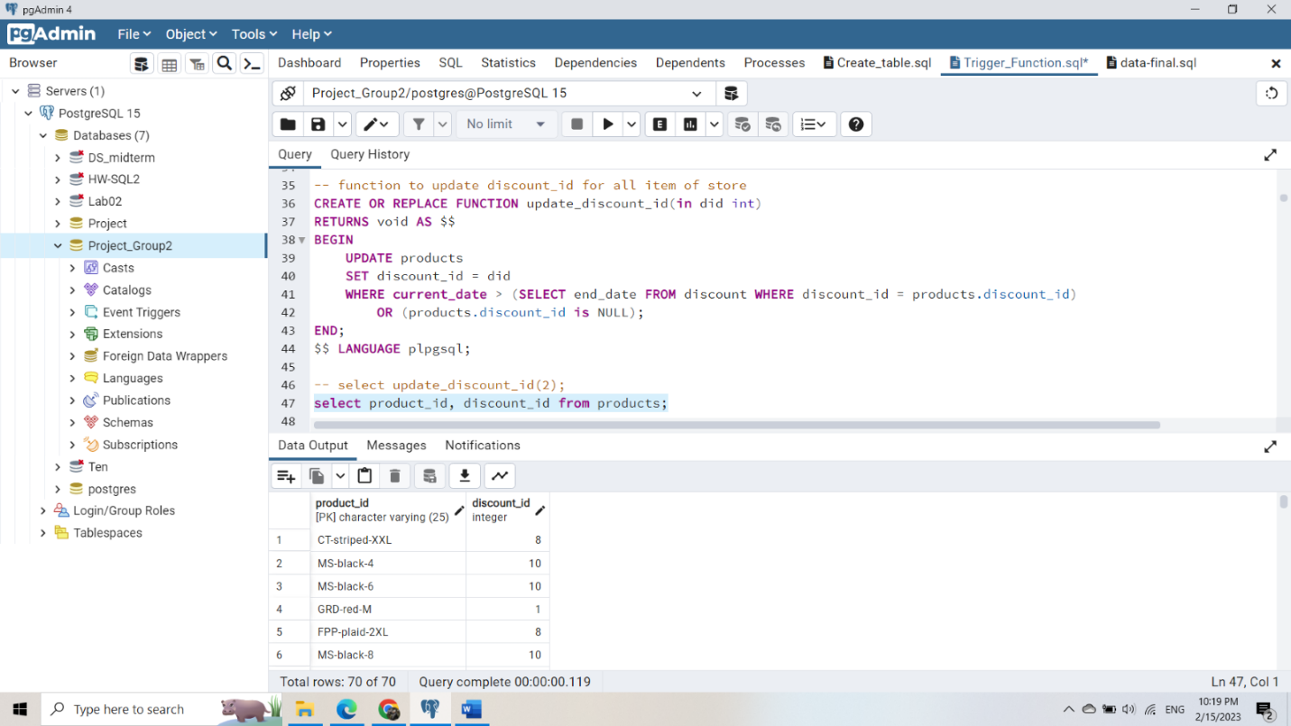

**After update:**

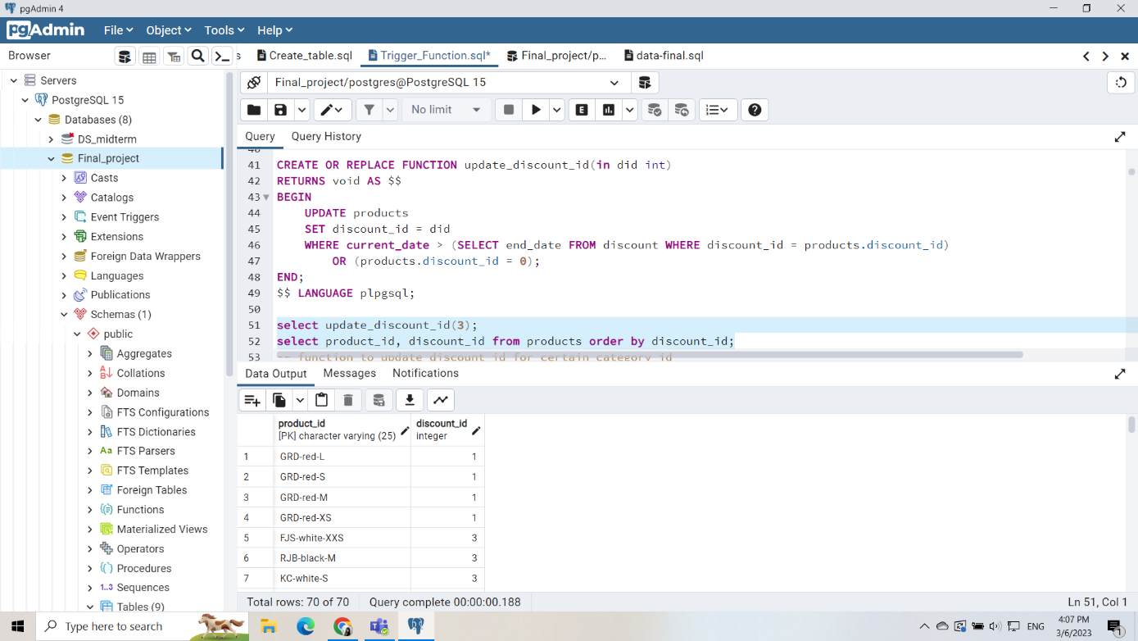

### **Update discount_id for certain category_id**

**Before update**

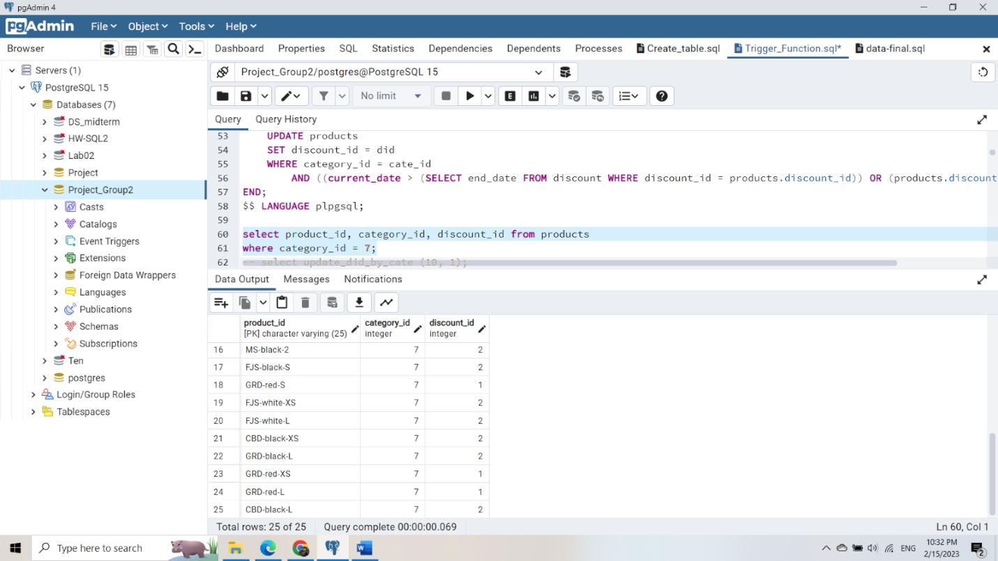

**After Update**

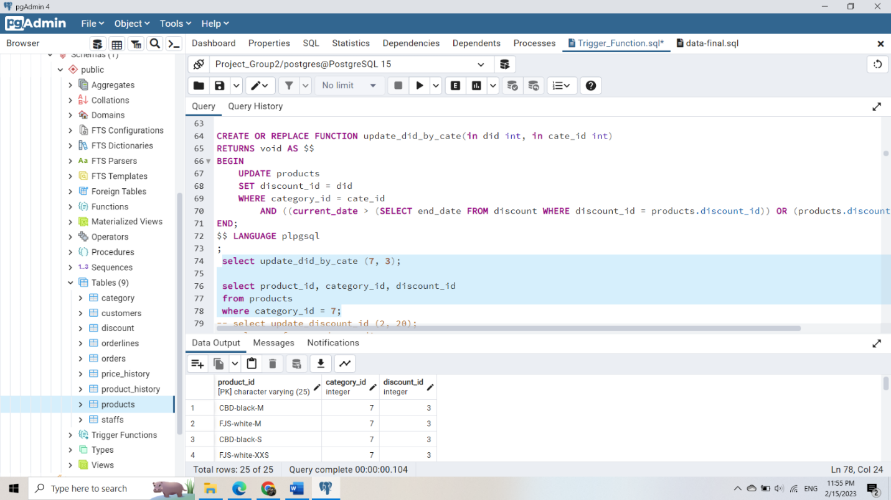

### **Calculate total_amount for certain period**

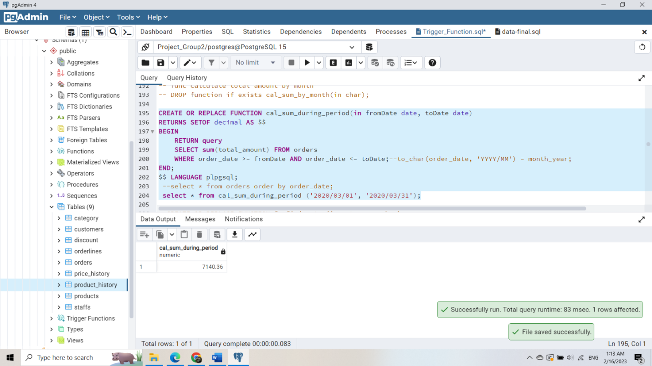

### **Function to show sale history of staff**

* View to join staffs with orders:

CREATE OR REPLACE VIEW view_staff_order AS

SELECT

s.username as v_username,

s.first_name||' '||s.last_name AS v_name,

o.order_id as v_order_id,

o.order_date as v_order_date,

o.total_amount as v_total_amount

FROM staffs s, orders o

WHERE o.staff_id = s.username;

* Function:

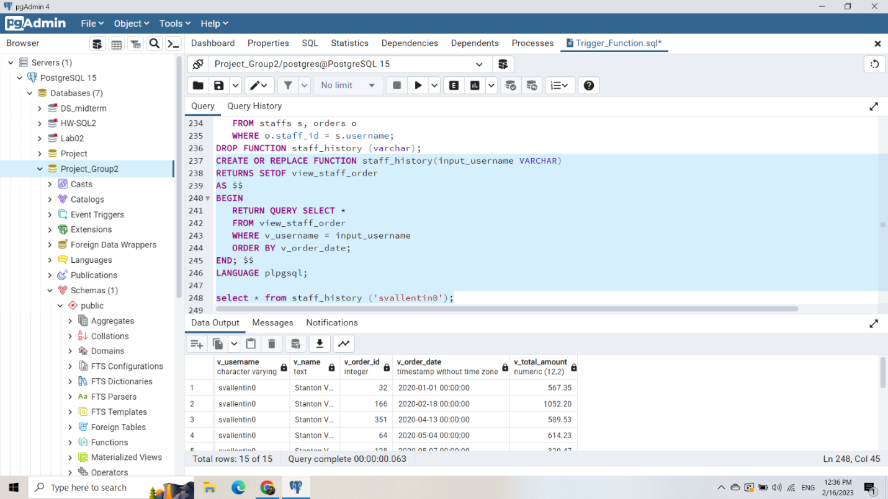

### **Function to show history between a period of time**

* **View to join staffs, orders, customers:**

CREATE OR REPLACE VIEW view_staff_order_cus AS

SELECT

c.first_name||' '||c.last_name AS v_cus_name,

c.phone v_phone,

o.order_id v_order_id,

o.order_date v_order_date,

o.total_amount v_total_amount,

s.username as v_username,

s.first_name||' '||s.last_name AS v_staff_name

FROM staffs s, orders o, customers c

WHERE o.staff_id = s.username

AND o.customer_id = c.phone;

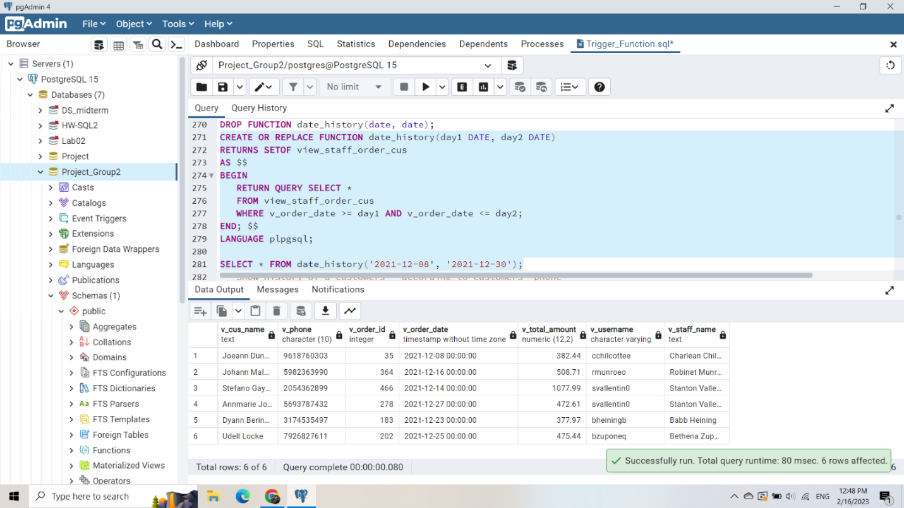

### **Function show history of a customer - according to customers' phone (using view)**

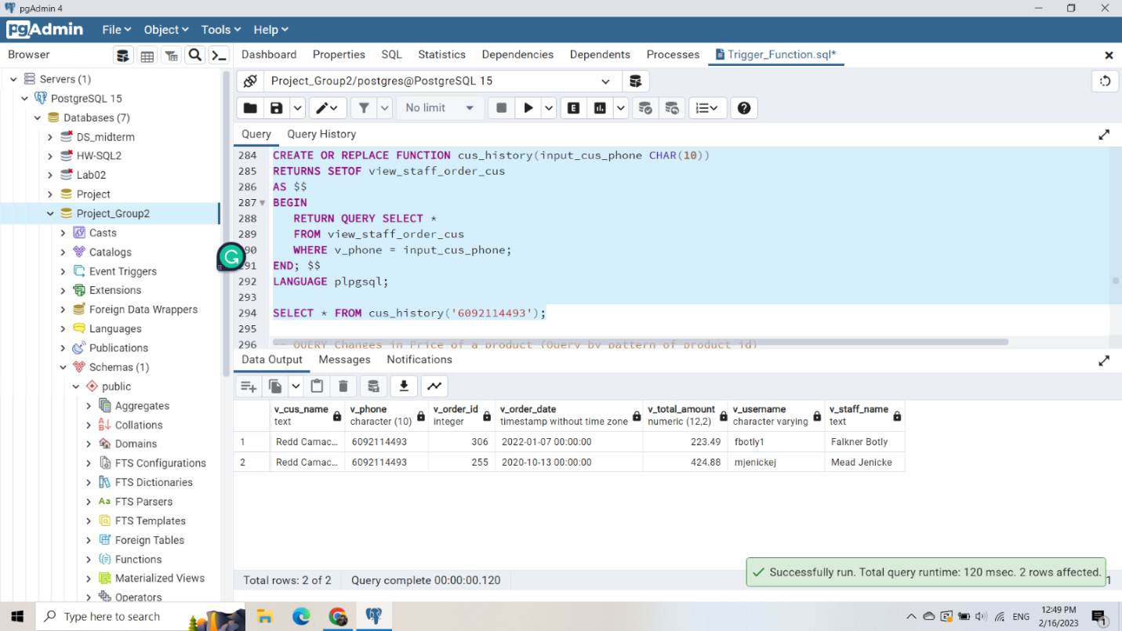

### **Function to show changes in Price of a product (Query by pattern of product_id)**

View:

CREATE OR REPLACE VIEW view_prod_his AS

SELECT p.product_id as v_prod_id, p.name, h.date_in, h.new_price

FROM products p, price_history h

WHERE p.product_id = h.product_id;

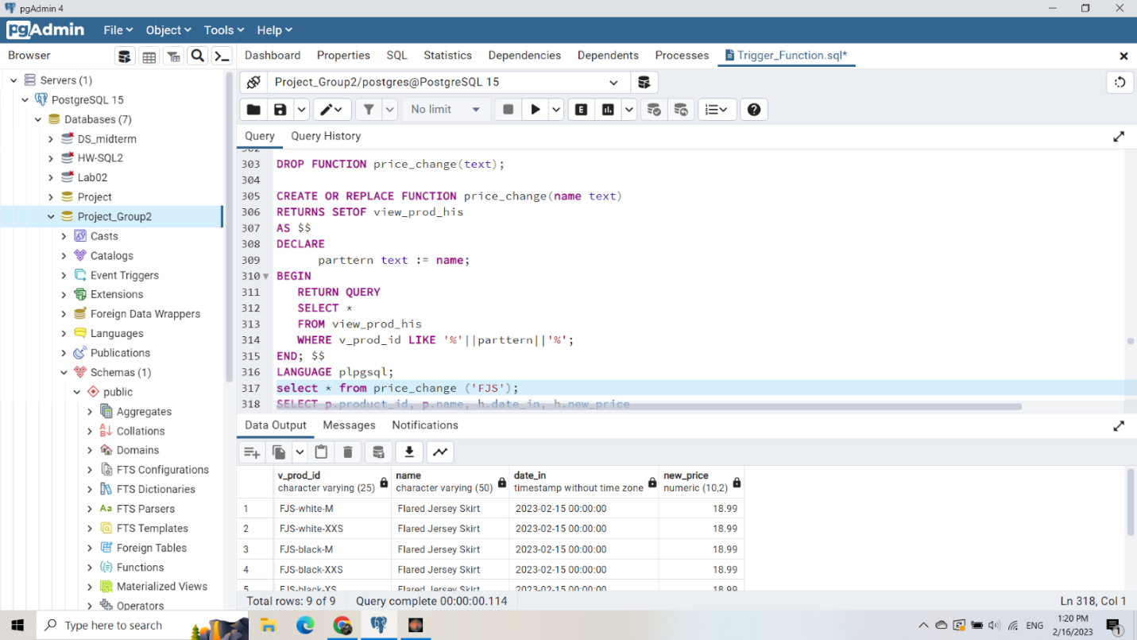

### **Function to find product of the same category (search by category name)**

Using view:

CREATE VIEW view_prod_cate AS

SELECT p.product_id, p.name as v_prod_name, p.quan_in_stock, c.name as v_cate_name

FROM products p, category c

WHERE p.category_id = c.category_id;

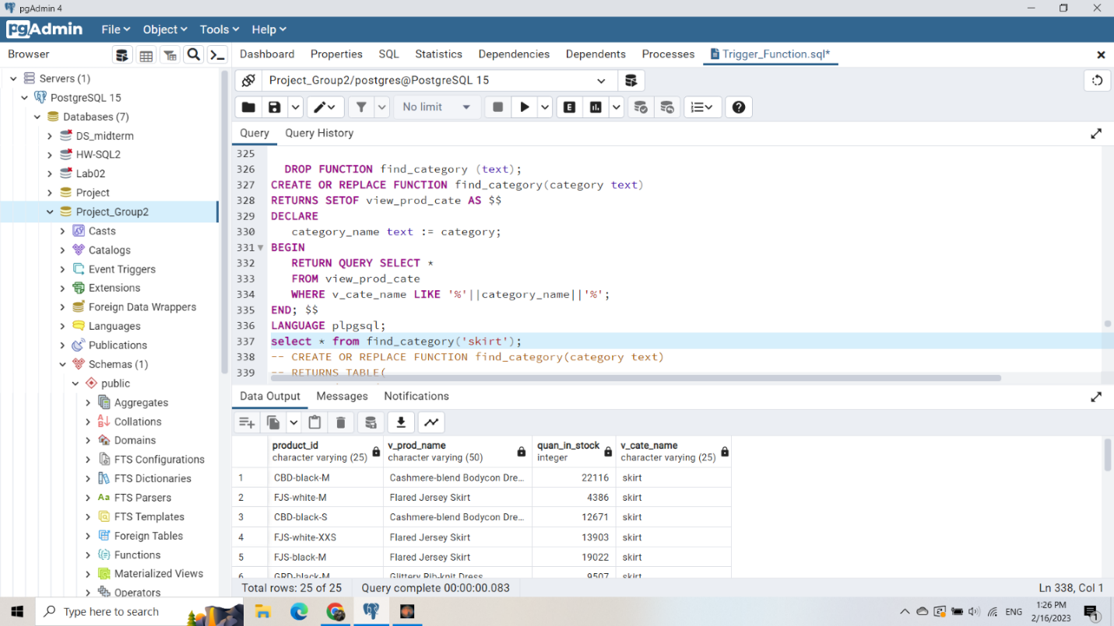

### **Function to show the money coming in and out through a period**

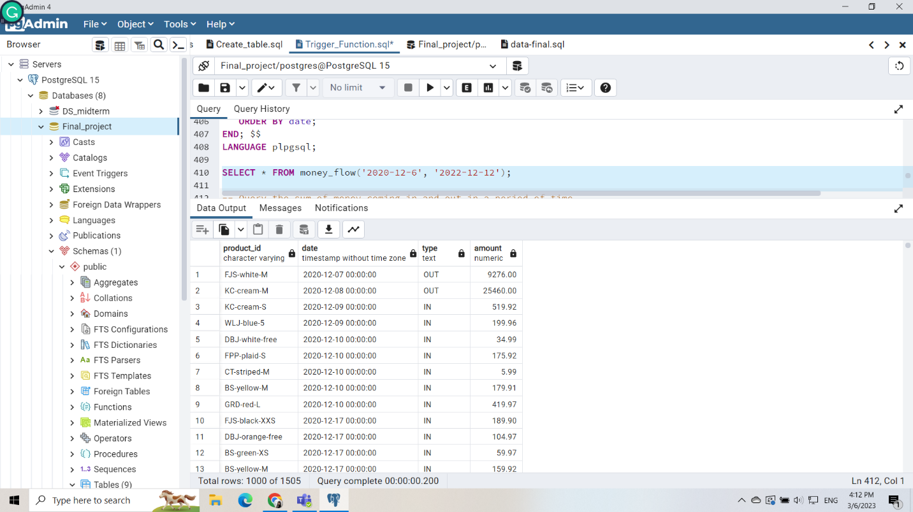

### **Function shows the sum of money coming in and out in a period**

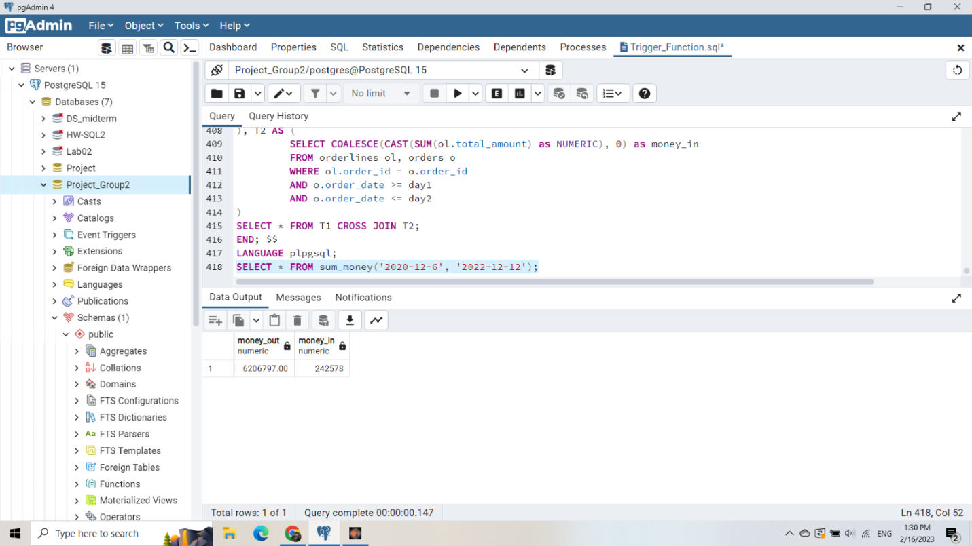

### **Function filters order by total_amount**

* Using index orders(total_amount)

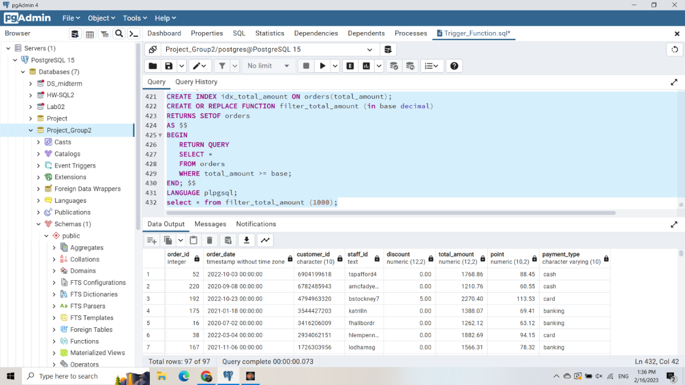

## **ANALYSE USING VIEW**

### **Query without view:**

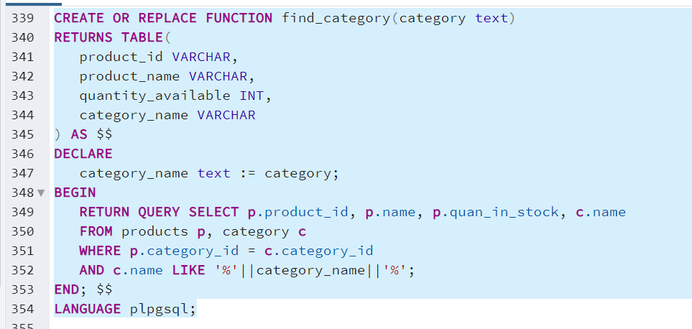

### **With view, the query is simpler:**

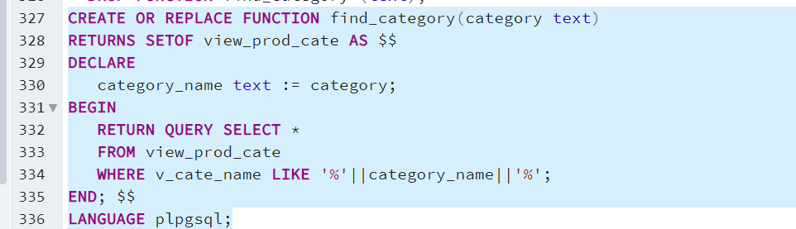

## **ANALYSE USING INDEXS**

### **Without index:**

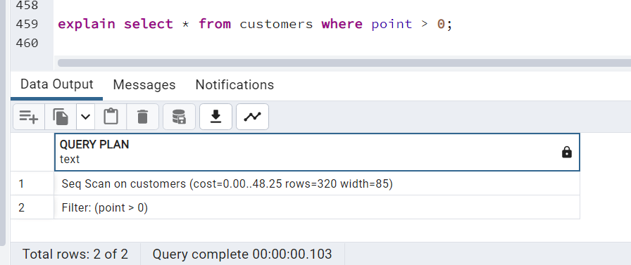

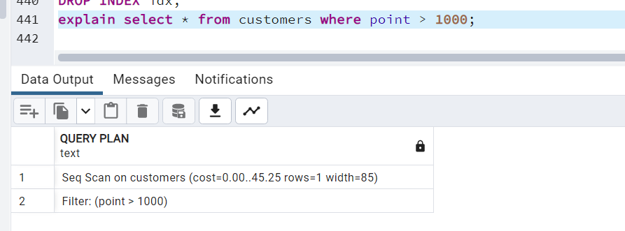

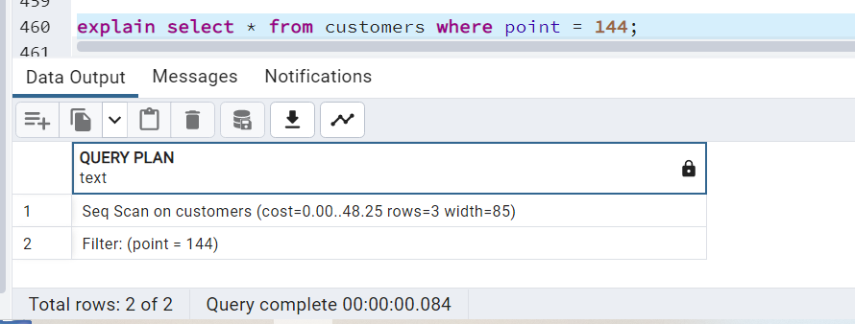

### **Using BTREE index:**

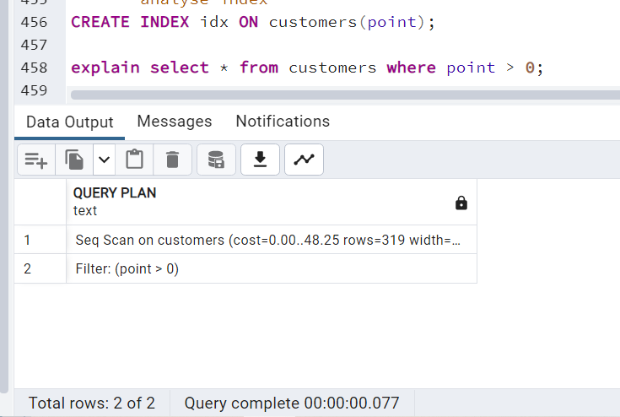

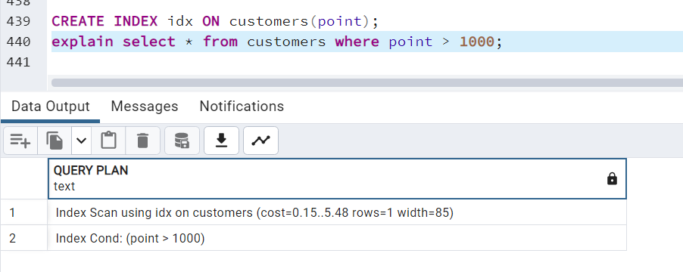

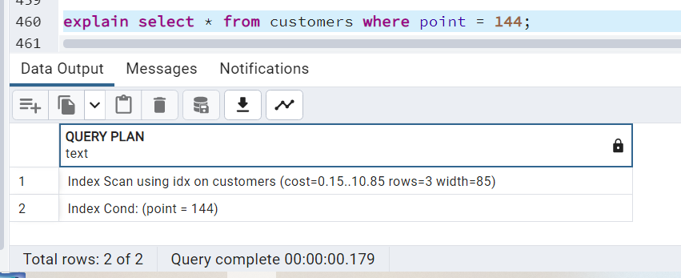

### **Using HASH index:**

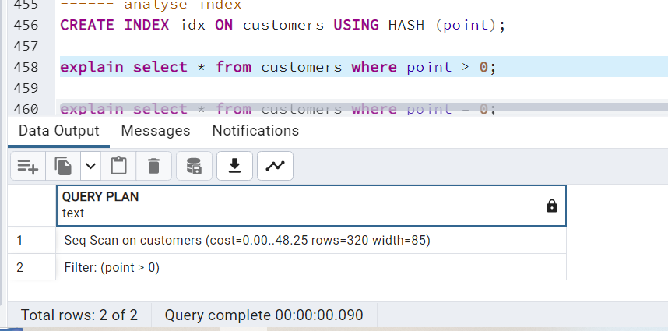

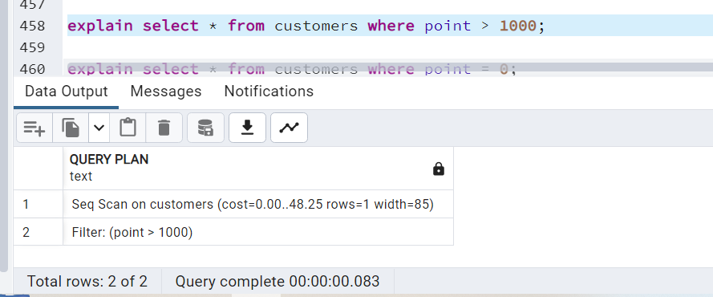

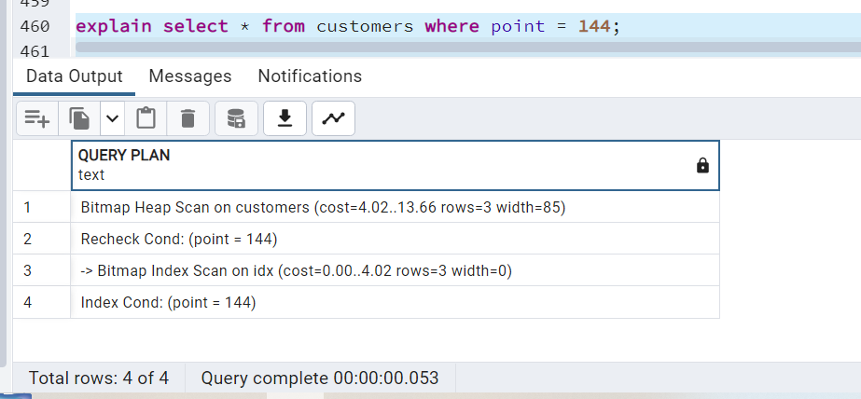

* **Comment:**
  + ***Experiment 1: Show all customers whose point > 0***

In all 3 cases, the DB executes the same query plan, there is no difference between using index or not using index.

Explain: when filtering with small bounds, the DB still needs to traverse almost the entire table, so using the index is not necessary.

* + ***Experiment 2: Show all customers whose point > 1000***

Btree-index is effective in this case, it reduces the cost significantly (from 0.00 .. 48.25 to 0.15..5.48). B-tree index helps the database not to scan the entire table to find the data, but just search starting at the root node, and search up to the branch and leaf, until all the data is found. query condition

* + ***Experiment 3:*** ***Show all customers whose point = 144***

Both Btree-index and hash index are used in this scenario and help improve performance. But it seems hash index runs faster.

* **Conclude:**
  + Should use Btree-index with operators =, <>, >, < provided that the comparison is with a large enough number
  + Hash-index is efficient when searching with the = operator, not for word math searching for a range of values like > or <
  + In other cases, the index should not be used, because the index even degrades the performance when the database takes more time, space to save index and consider whether the index is effective or not.

# **User Interface**

## **Manage Staffs**

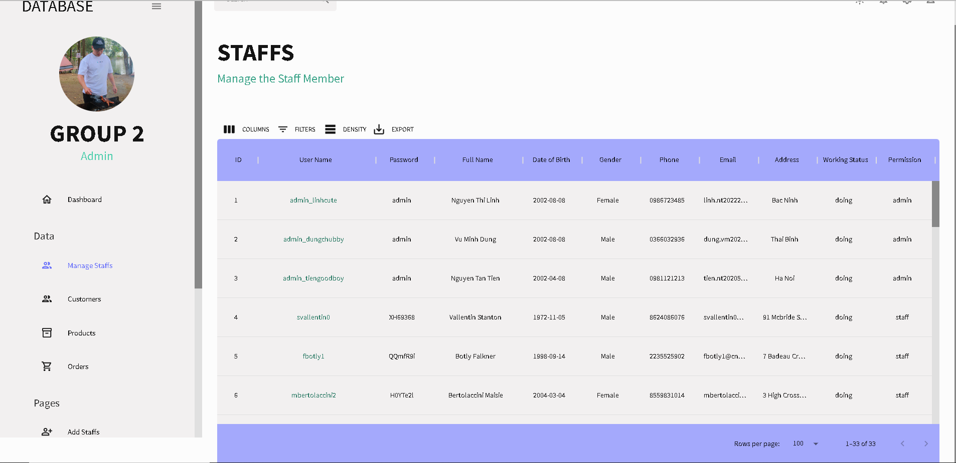

* In page staffs, we manage every information about Staffs such as: username, password, name, date of birth, gender, phone number, ….
* We can search staffs by any components such as: search by name, search by phone….

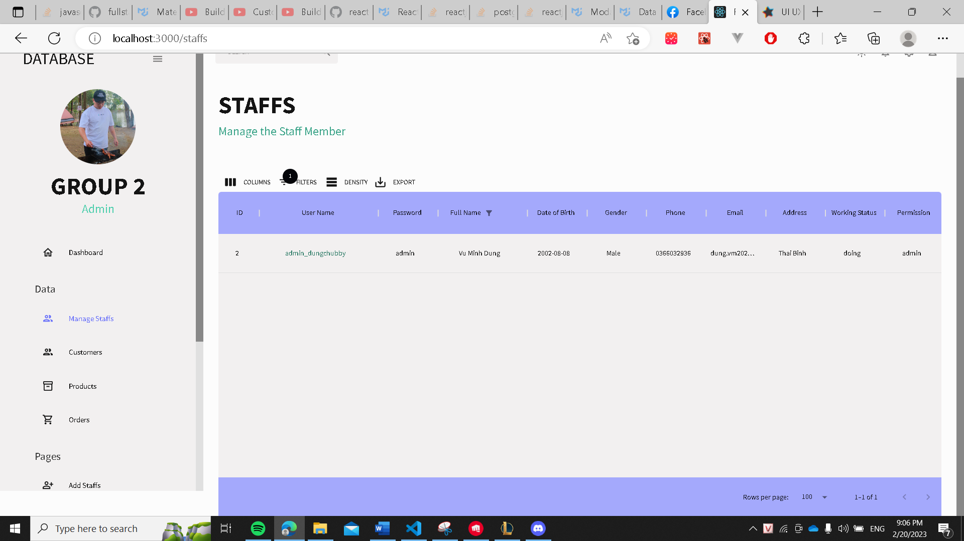

## **Manage Customers**

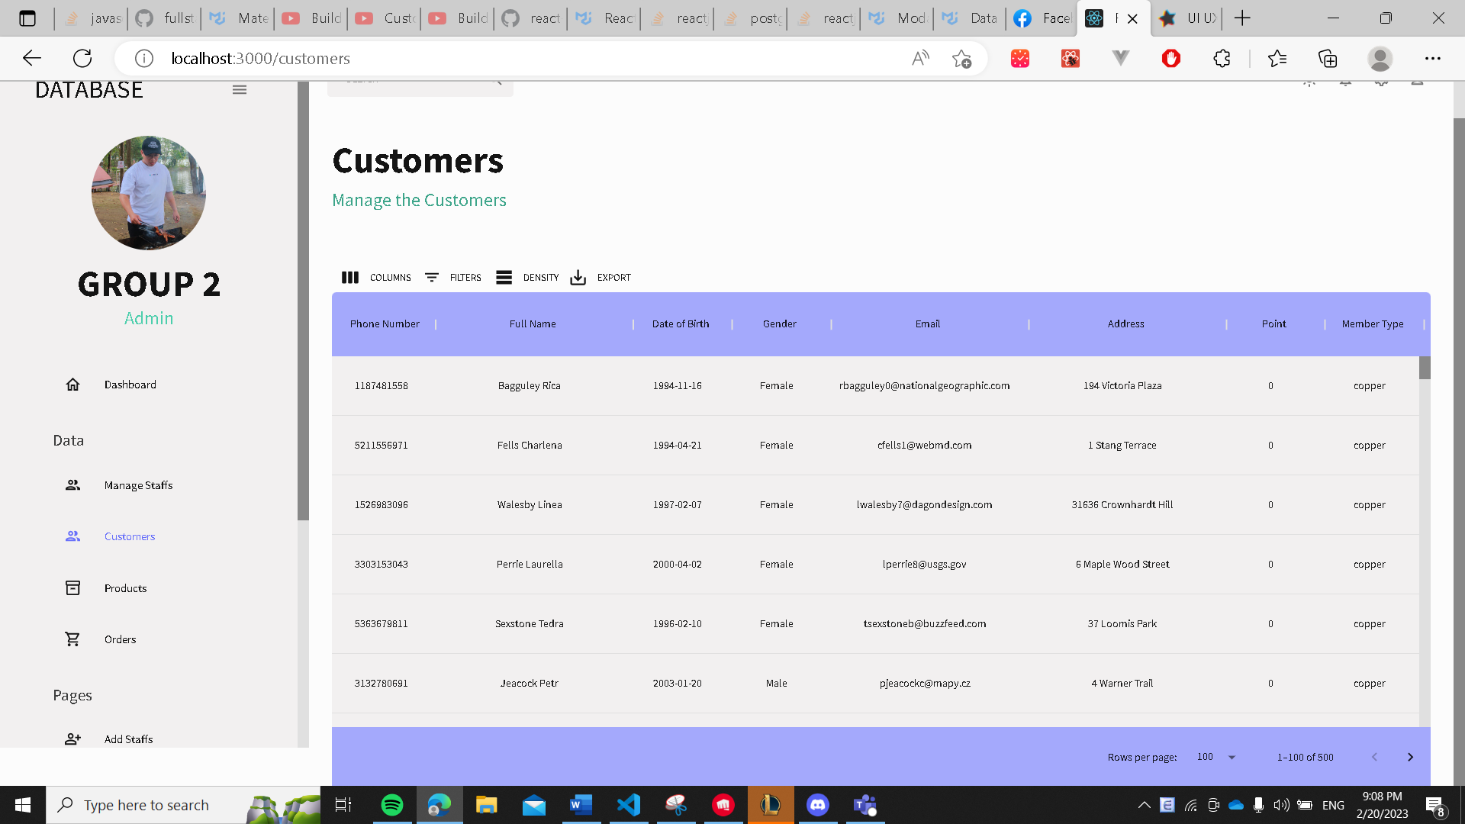

## **Manage Products**

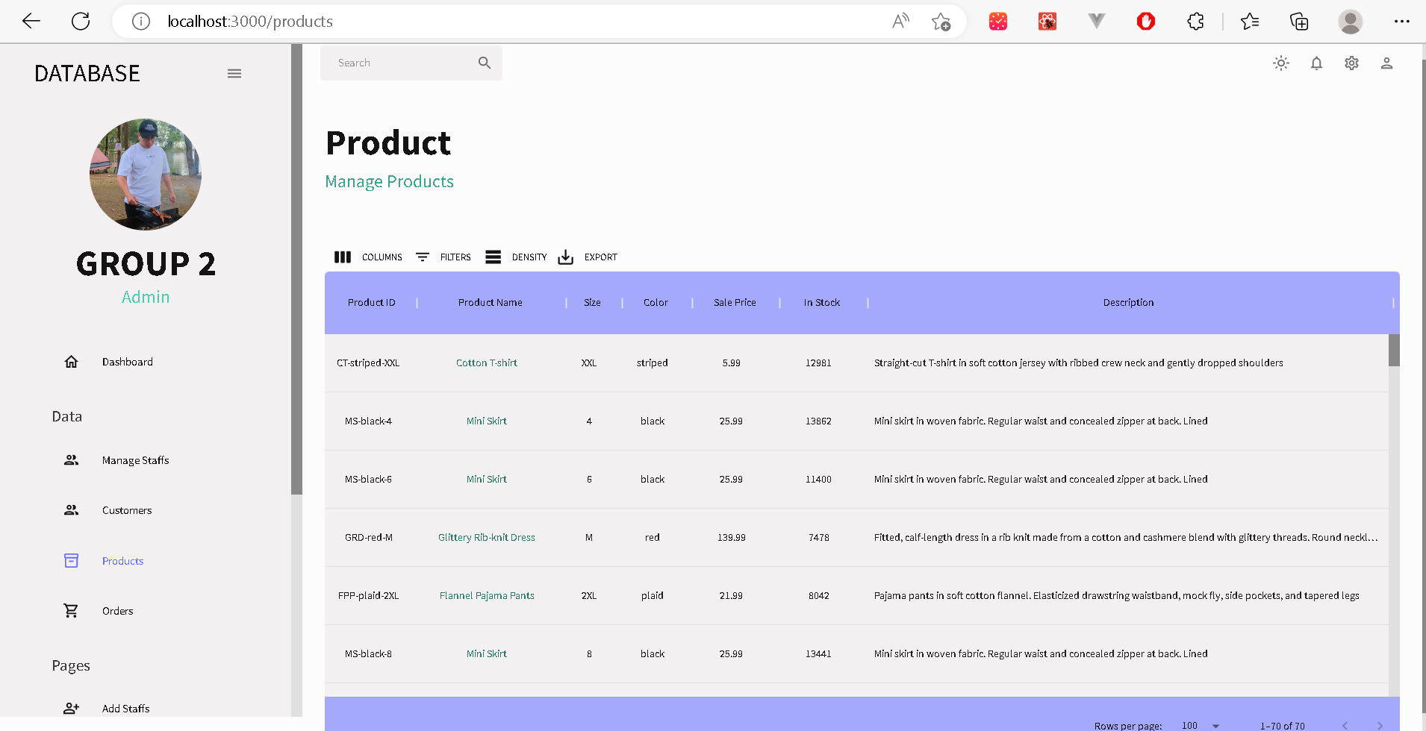

## **Manage Orders**

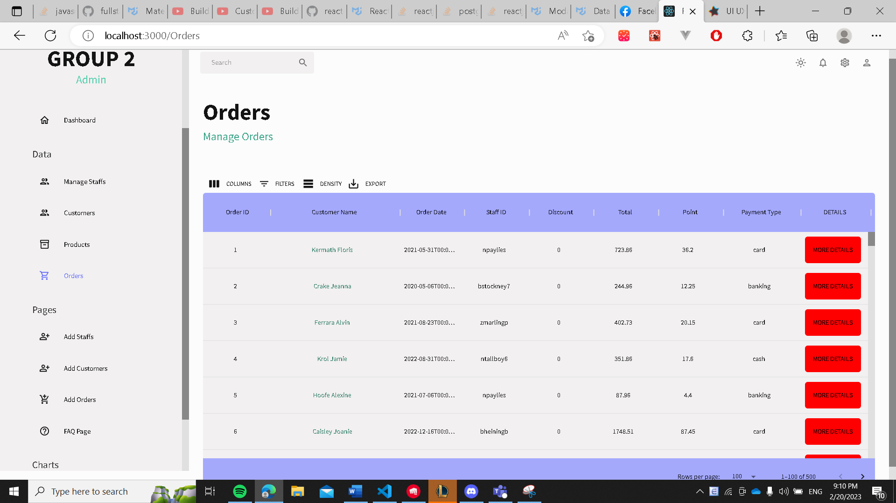

* By clicking “MORE DETAILS” button, we can see every orderliness of that order. For example:

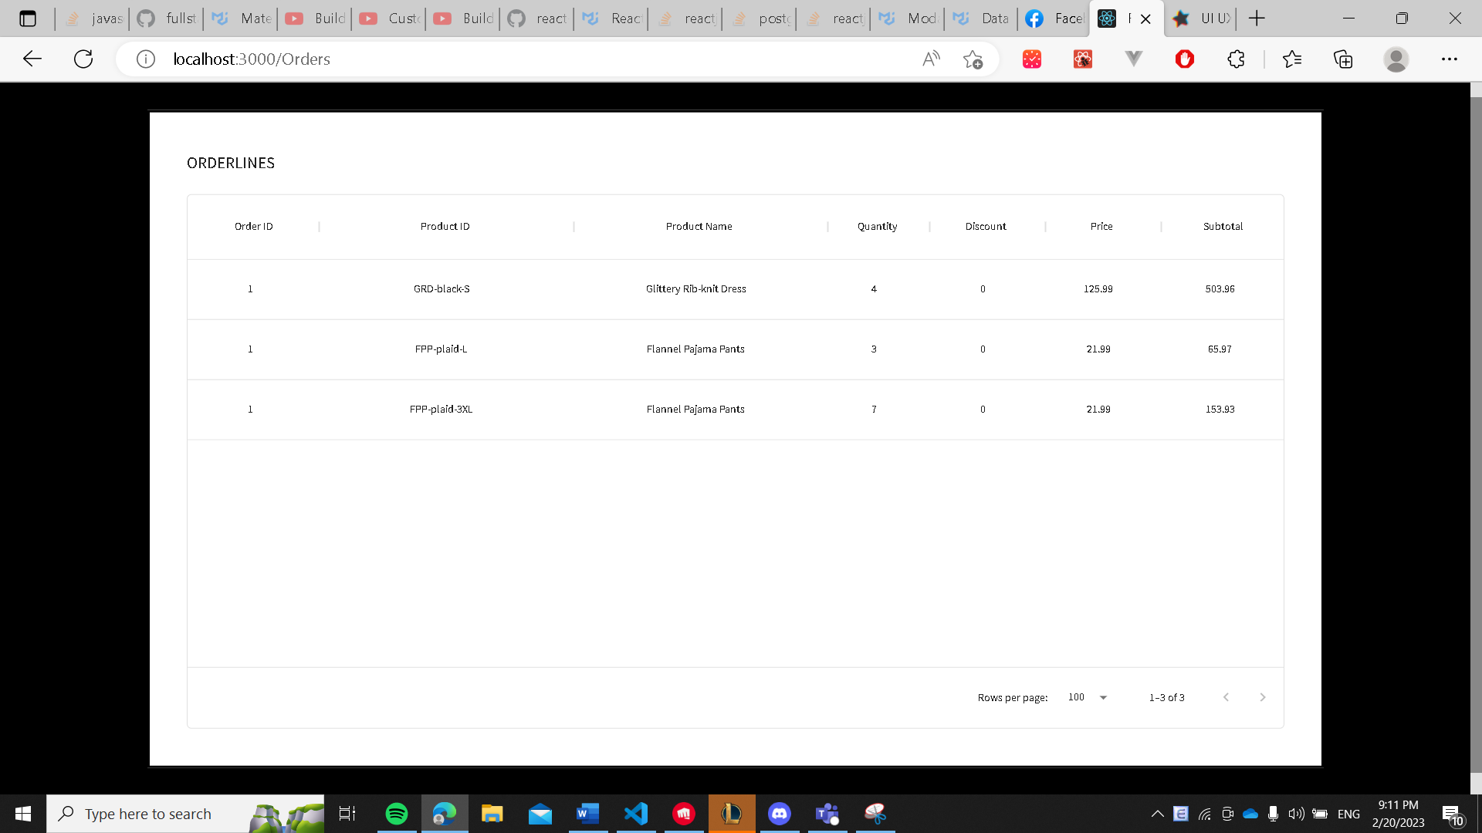

* Order (1) contains 3 orderliness.

# **Lesson learned from this project**

* The design of the database must follow the recommended order. When we first designed the database, we made the mistake of jumping directly to the drawing of tables without careful plannings. As a result, we must alter most of the table and the process is unnecessary complicated.
* The use of View allows shorter syntax and reduced execution time thanks to the feature of saving the query plan of VIEW.
* The use of FUNCTION will come in handy when we must execute one type of query many times.
* The use of index will help to reduce cost of query significantly in certain situations (as shown above)

*This summary is the first trial of our team about the total database design and implementation. There will definitely be some mistakes or unsuitable features that need adjusting. Thus, we would really appreciate any of your comments to help us perfect our work! Thank you!*